SFWR ENG 3RA3 Summary

Author: Kemal Ahmed

Instructor: Dr. Ryszard Janicki

Date: Fall 2014

*Math objects made using* [*MathType*](http://www.dessci.com/en/products/mathtype/)*; graphs made using* [*Winplot*](http://math.exeter.edu/rparris/winplot.html)*.*

Please join GitHub and contribute to this document. There is a guide on how to do this on my GitHub.

Table of Contents

Lecture 2 – Types of Statements 2

Lecture 3 3

Lecture 5 4

Defining Requirements 4

Knowledge Acquisition 5

Lecture 6 5

Lecture 7 5

Lecture 8 6

Risk Trees 6

Cut Set 6

Qualitative Risk Assessment 6

Quantitative Risk Assessment 6

AHP Comparison Matrix 7

Pairwise Comparisons 7

Risk Consequence Table 8

Risk Countermeasure Table 8

Entity Relationship (ER) Diagram 8

e.g.) 9

Data Flow Diagrams 9

e.g. 10

Activity Diagram 10

State Machine Diagram 11

Lecture 13 11

Fit Criteria 11

Entity Relationship Diagrams 11

Lecture 15 11

Lecture 17 11

Before-After Predicates 11

Lecture 18 12

Review Process 12

SCR Tables 13

Lecture 20 13

Traceability Matrices 13

Lecture 24 13

Security Levels 13

Bell-LaPadula Model 13

Lecture 25 14

Low Water-Mark Policy 14

Ring 14

Strict Integrity 15

Lecture 26 15

Lecture 28 16

Vigenère Cipher 16

# Lecture 2 – Types of Statements

**Software Requirements Specification (SRS)**: description of a software system that will be developed

**Descriptive Statement**: facts about the system, such as natural laws and physical constraints

* Domain Property (DOM): affecting environmental phenomena, such as physics

**Prescriptive Statement**: desired behavioural properties of a system; can be negotiated

Types of prescriptive statements:

* **System Requirement** (SYSREQ): when the software interacts with the other system components, i.e. environment
  + vocabulary understandable by all parties
  + Types of SYSREQ:
    - Assumptions (ASM): how the environment should be, usually through sensors and stuff
  + SOFREQ, ASM, DOM |= SYSREQ
    - When the SOFREQ, ASM, and DOM are satisfied, SYSREQ is satisfied
* **Software Requirement** (SOFREQ): relationship between a set of input variables, *I*, and *O*, the set of output variables
  + vocabulary understandable by software developers

# Lecture 3

**Non-functional requirements**

* Look and Feel Requirements:
  + Appearance Requirements
  + Style Requirements
* Usability and Humanity Requirements:
  + Ease of Use Requirements
  + Personalization and Internationalization Requirements
  + Learning Requirements
  + Understandability and Politeness Requirements
  + Accessibility Requirements
* Performance Requirements:
  + Speed and Latency Requirements
  + Safety-Critical Requirements:
  + Precision or Accuracy Requirements
  + Reliability and Availability Requirements
  + Robustness or Fault-Tolerance Requirements
  + Capacity Requirements
  + Scalability or Extensibility Requirements
  + Longevity Requirements
* Operational and Environmental Requirements:
  + Expected Physical Environment
  + Requirements for Interfacing with Adjacent Systems
  + Productization Requirements
  + Release Requirements
* Maintainability and Support Requirements:
  + Maintenance Requirements
  + Supportability Requirements
  + Adaptability Requirements
* Security Requirements:
  + Access Requirements
  + Integrity Requirements
  + Privacy Requirements
  + Audit Requirements
  + Immunity Requirements
* Cultural and Political Requirements
  + Cultural Requirements
  + Political Requirements
* Legal Requirements:
  + Compliance Requirements
  + Standards Requirements
* Open Issues: Issues that have been raised and do not yet have a conclusion
* Oﬀ-the-Shelf Solutions: is there anything that is ready made (components or full product) or even something you can copy

**Safety Critical Systems**: systems that ensure the safety of the users of the system. Generally, they are components of a larger system, [e.g.](https://en.wikipedia.org/wiki/Life-critical_system#Examples_of_life-critical_systems)

* Fire alarm
* Circuit breaker
* Airbags

# Lecture 5

## Defining Requirements

Types of projects:

* Rabbit:
  + Agile
  + Short life
* Horse:
  + Fast, strong, dependable
  + Most common in corporate
  + Medium longevity
* Elephant:
  + Solid, strong, long life

**Artifact-driven**: basing the requirements on data collection, questionnaires, etc.

* You can often collect too much data
* Only keep what you need to know
* *prune* the document space, so you only keep the useful data.

**Scenario**: similar to *storyboards*…

**Positive Scenario**: behaviour system should cover

* **Normal Scenario**: everything proceeds as expected
* **Abnormal Scenario**: an unusual behaviour, but the system still covers it

**Negative Scenario**: behaviour system should exclude, i.e. a mistake of the system

## Knowledge Acquisition

**Stakeholders**: important to identify when determining who to customize the project towards

* Who is responsible for funding/using/managing the project?
* Caution: interactions with them must be done carefully

**Domain expertise**: what does the domain know / qualifications? Domain is who the project is directed towards

# Lecture 6

**Stakeholders-driven Elicitation Techniques**: methods of knowledge acquisition

* Interviews
  + Single interview for multiple stakeholders: faster, but less involving
  + Steps:
    - Select stakeholders
    - Background study
    - Predesign sequence of questions, focused on concerns of present stakeholder(s)
    - Begin by asking easy questions
    - Keep focus during interview
    - Ask ‘why’-questions
    - Record answers and reactions
    - Write report from transcripts
    - Confirm report with stakeholders interviewed
  + Types:
    - **Structured**: predetermined set of questions
    - **Unstructured**: free discussion of current system
    - Optimal: start with *structure*, then do *unstructured*

Observation:

* people behave differently when observed
* slow & expensive

Group sessions: more than 4 people

# Lecture 7

**Inconsistencies**: conflicting views or incorrect

**Boundary Condition**: the sample of instances where conditions conflict

**Divergence**: when two viewpoints have boundary conditions; they must be clarified

**Strong conflict**: non-satisfiable to the point of being logically inconsistent

**Weak conflict**: satisfiable without boundary condition

# Lecture 8

**Defect Detection Prevention (DDP)**: quantitative approach to risk analysis

DDP Risk management includes:

* Risk Consequence Tables
* Risk Countermeasure Tables

## Risk Trees

**Risk Trees**: (a.k.a. **fault tree**) a visual way of breaking down the causes of potential risks to identify where special attention needs to be placed in the design process

Components:

* Rectangles: can have children
* Ellipses: leaf nodes; may not have children
* AND / OR gates: you know how they work…

### Cut Set

**Cut set**: the set of causes that result in the risk occurring

(diagram on right)

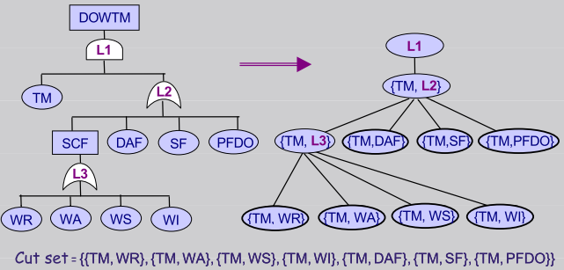

Think: sum of products

## Qualitative Risk Assessment

|  |  |  |  |
| --- | --- | --- | --- |
| Consequences | **Risk Likelihood** (*probability*) | | |
| Likely | Possible | Unlikely |
| *risk 1* | *Outcome* | *Outcome* | *Outcome* |

Outcome can be Low, Moderate, High, Severe, or Catastrophic

## Quantitative Risk Assessment

|  |  |  |  |  |  |  |
| --- | --- | --- | --- | --- | --- | --- |
| **Consequences** | **Risk Likelihood** | | | | | |
| Likelihood levels  0.3 | | 0.6 | | 0.1 | |
| Likely | | Possible | | Unlikely | |
| *risk 1* | *Outcome* |  | *Outcome* |  | *Outcome* |  |

**Likelihood levels**: the total must equal one for the 

## AHP Comparison Matrix

**Analytic Hierarchy Process (AHP)**:

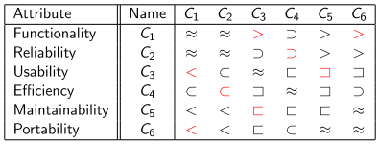

# Pairwise Comparisons

This is a way of seeing if your values for your AHP matrix are consistent.

**Weights [w]**: measure of importance from 0 to 1

**Relationship Quantity [a]**:



Although the sum of your weights, should equal 1, don’t worry if it doesn’t. Instead, normalize them by dividing them all by the sum of your weights.



*axy*, where *x* is columns and *y* is rows

Also:

* for a(x<y), a(x,y) = 1.0/a(y,x)
* for a(x=y), a(x,y) = 1.0

*i*, *j*, and *k* are index variables with a range of the number of elements

a: *aij*; so *i* = *x*, *j* = *y*

b: *aik*

c: *akj*

**Inconsistency coefficient** [cmA]: 

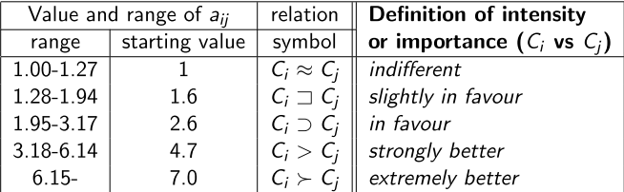

If the inconsistency coefficient is > 0.3, then you need to tweak your values.

## Risk Consequence Table

For the table, fill in the *italic* parts.

Variables:

*w*: weight

*l*: likelihood

*i*: impact level

|  |  |  |  |
| --- | --- | --- | --- |
| **Objectives** | **Risks** | |  |
|  | *risk 1* (likelihood: *likelihood*) | *risk 2* (likelihood: *likelihood*) | **Loss obj.** |
| *Objective 1* (weight: *weight 1*) | *Impact level* | *Impact level* |  |
| *Objective 2* (weight: *weight 1*) | *Impact level* | *Impact level* |  |
| **Risk Criticality** |  |  |  |

## Risk Countermeasure Table

*e*: effectiveness

|  |  |  |  |
| --- | --- | --- | --- |
| **Consequences** | **Risks** | |  |
|  | *risk 1* (likelihood: *likelihood*) | *risk 2* (likelihood: *likelihood*) | **Effectiveness of Countermeasure** |
| *Countermeasure 1* | *Effectiveness* | *Effectiveness* |  |
| *Countermeasure 2* | *Effectiveness* | *Effectiveness* |  |
| **Risk Reduction** |  |  |  |

## Entity Relationship (ER) Diagram

|  |
| --- |
| **Entity**: class of concept instances |
| Attribute 1  …  Attribute *n*: intrinsic feature of an entity (regardless of other entities); public variables stored in the class, like hasHair or eyeColour for an Animal class |

|

| relationshipName

|

|  |
| --- |
| Entity 2 |

**arity**: range of entities that contribute to the relationship

### e.g.)

|  |
| --- |
| participant |
| Name Address  e-mail |

arity↓ |

1..* | invitedTo

| Invitation

0..* | invites

|

## Data Flow Diagrams

**Rectangles**: actors outside of system (i.e. entities) who either input to or receive output from the system

**Arrows**: direction of flow of information, the description of the information is usually described along the length of the arrow

**Circles / State Boxes**: actions by system

**Database containers**: accesses from / inputs to specified database

### e.g.



## Activity Diagram

(actually not in the slides; copied from SFWR ENG 3A04)

**Activity Diagram**: data and control flow of system

* Rounded rectangles: actions in system
* Solid hub: fork and joint points
* Surrounded disk: terminate
* Diamond: decision
* Disk: start point

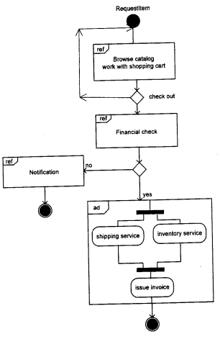

## State Machine Diagram

Arrow:

* [constraint]: necessary input to get to next state
* flow: what the machine is doing

Circles: description of state

All states must go to a termination state!

# Lecture 13

## Fit Criteria

**Fit criteria** is the criteria that determines how well a solution fulfills the desired requirements

**Non-functional**: rationale, scale

**Functional**: how well did it satisfy the functions?

They *fit* if they are measureable

## Entity Relationship Diagrams

**entity**: something external that interacts with your system

A way of representing a system, using entities

* **Rectangles** represent entity sets
* **Diamonds** represent relationship sets
* **Lines** link attributes to entity sets and entity sets to relationship sets
* **Ellipses** represent attributes
  + **Double ellipses** represent multivalued attributes
  + **Dashed ellipses** denote derived attributes
* **Dashed ellipses** denote derived attributes
* **Underline** indicates primary key attributes

# Lecture 15

**Use Case Diagrams**:

**Extend**:

**Include**:

# Lecture 17

## Before-After Predicates

**Before**:

*attribute* : entity → {set of potential values of attribute}

**After**:

Processing based on values of attributes

e.g.

hasAuthorization(p) ∧ carriesPassport(p) ∧ ¬inBuilding(p) ⇒

peopleInBuilding’ = peopleInBuilding ∪ {p} ∧

passportsAtDesk’ = passportsAtDesk ∪ {passportOf (p)} ∧

inBuilding(p) ∧ ¬carriesPassport(p)

*If you* (p) *have authorization and a passport and you’re not in the building, then peopleInBuilding becomes peopleInBuilding + you. Also, your passport is added to the list of passports on the desk. Also, you enter the building and you’re no longer carrying your passport because you handed it into the front desk.*

# Lecture 18

**Temporal Logic**: specifying and verifying properties of time-based systems

**Linear Temporal Logic**: an infinite sequence of states where each point in time has a unique successor

**Linear temporal property**: a temporal logic formula that describes a set of infinite sequences for which it is true

|  |  |
| --- | --- |
| Future: the event occurs… | Past: the event occurred… |
| ◊ (**F**) : some times in the ***F****uture*  □ (**G**): always in the *future*; **G**lobally  ○ (**X**): to be held at the ne**X**t state  **W** : always in the *future* unless  **U** : always in the *future* until | ♦ : some times in the *past*  □−1: always in the *past*  **S**: always in the *past* **S**ince  **B**: always in the *past* **B**ack to |

Note: future symbols can be mirrored as past by using the inverse sign or filling them in

Whitebox testing: Inspection

## Review Process

Blackbox testing of system

* Free mode: no directive on where to find what
* Checklist-based: specific issues, defect types, RD parts
* Process-based: specific role for each reviewer, specific procedure, defect type, focus, analysis technique

**Revision**: updates of certain components and removing obsolete parts

**Variant**: different versions for different purposes

*affects*:

*depends On*:

## SCR Tables

Each table outlines how one part of a system is set across all modes.

# Lecture 20

**Stability**: the probability of a feature to not change

## Traceability Matrices

Types:

* Between Requirements
  + One axis is functional requirements
  + Other axis is non-functional requirements
  + *Which non-functional requirements satisfy the functional requirements?*
* Requirements and *test cases*
  + **Test case**: an example of how someone should use the system
  + One axis is functional requirements
  + Other axis is test cases
  + *Are the functional requirements useful?*

# Lecture 24

Confidentiality: prevents the unauthorized disclosure of information

Integrity: unauthorized alternation of information

Availability:

disclosure: unauthorized access to information

disruption: interruption or prevention of correct operation

deception: acceptance of false data

usurpation: unauthorized control of some parts of a system

## Security Levels

Think of **category sets** as a ring of keys that a person has. If someone has the keys {A, B}, they can open a door (access the document) with the locks {A}, {B}, and {A,B}. However, they can’t open the doors {C}, {A,C}, {B,C}, nor {A,B,C}, even though they have some of the keys for the last 3 examples.

Mathematically

C(person) ⊋ C(document), you get read,

C(document) ⊋ C(person), you get write,

but if neither, then neither.

Note: 

## Bell-LaPadula Model

**Security Clearance [I**] OR **[i(s)]**: the privileges of a subject

**Agent Security Clearance [IS]**: what is the person authenticated to? also could refer to a program / function that can execute other programs / functions

**Object Security Clearance [IO]**: what security does the information have?

Hierarchy [L] (from highest to lowest):

1. TOP SECRET
2. SECRET
3. CONFIDENTIAL
4. UNCLASSIFIED

This model works in conjunction with the security levels:

If the security levels work, then assume *S* is true:

* Write: IS ≤ IO ∧ S
* Read: IO ≤ IS ∧ S

# Lecture 25

**Biba**

* Low-Water-Mark:
* Ring:
* Strict Integrity:

## Low Water-Mark Policy

1. if s ∈ S reads o ∈ O, then i'(s) = min(i(s), i(o)), where i'(s) is the subject’s integrity level after the read,
2. Subjects can write to objects iff i(o) ≤ i(s),
3. Subjects can execute anything that other subjects can iff they have higher integrity than them

## Ring

* Subjects may read any objects, but there are restrictions on modification and execution
* Subjects can write to objects iff i(o) ≤ i(s)
* Subjects can execute anything that other subjects can iff they have higher integrity than them

[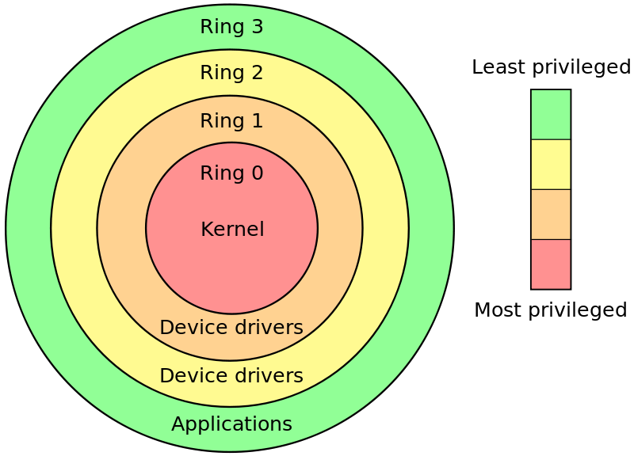](https://upload.wikimedia.org/wikipedia/commons/2/2f/Priv_rings.svg)

## Strict Integrity

* Pretty much Bell-LaPadula
* Read: i(s) ≤ i(o)
* Write: i(o) ≤ i(s)
* Execute: Subjects can execute anything that other subjects can iff they have higher integrity than them

# Lecture 26

**Private key [k]**: only one person can access it

**Public key [K]**: everyone can access it

**Diffie-Hellman scheme**: the first public-private key encryption method

Find *k* such that *n* = *gk* mod *p*, for a given set of natural numbers *n*, *g* and a prime number, *p*.





**Non-repudiation of origin**: when you know for sure and where the message came from

# Lecture 28

## Vigenère Cipher

A version of Caeser cipher, which uses a word as a key, instead of a single letter to shift. It takes the message, splits it into blocks the length of the key and shifts each block by the key.